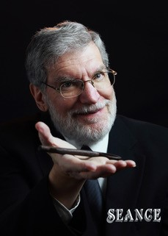
Scott Davis Bio

Scott Davis is an Emmy Award-winning filmmaker and award-winning independent book publisher. In the mid-1980s, Scott began editing the Psychic Entertainer’s Association newsletter, Vibrations, which gave him entrée to many of the most prominent figures in mentalism and bizarre magick, including publishers Bascom Jones, Tony Raven, Tony Andruzzi, and performers such as Eugene Burger, Max Maven, E. Raymond Carlyle, the first medium of the Magic Castle, and many more. In 1988, Scott founded Seance, the international quarterly magazine devoted to spirit magic. Acclaimed as “a gold mine filled with thought-provoking ideas for anyone interested in a magical engagement with ghosts and spirits,” the publication ran for three years and was later reprinted in a limited-edition hardcover book that is now a highly prized collector’s item.

